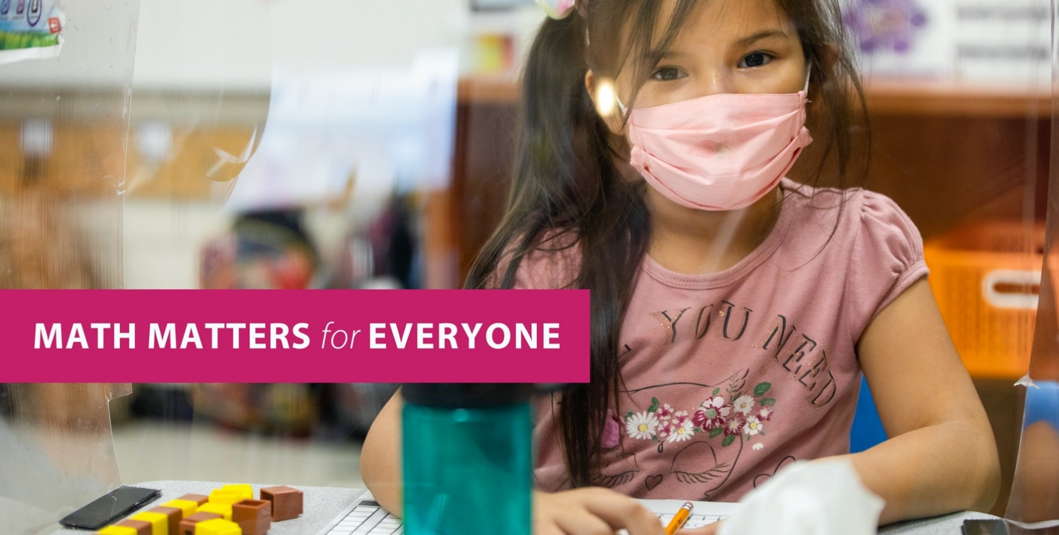

Yes, that includes you too!

Why care about learning advanced math now?
- Helps you feel good about yourself.
- Builds friendships as you solve problems together.
- Creates opportunities to explore the world around you.
- Gets you ready for next year!

The path to success starts early!
Do well in math so you can advance in math!

What can you do?
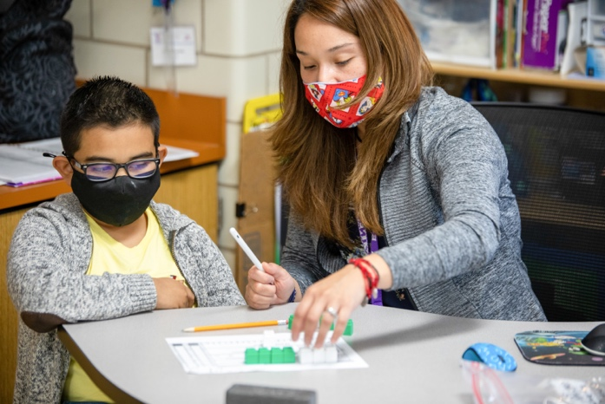
- Think positively and stick with it. Math is necessary, but also fun!
- Reach out to an adult for help when you feel like you’re not getting it.
- Talk to your teacher, counselor, or other adult about preparing for your next math class.

